Document Title: Flood Monitoring and Early Warning Project

Documentation:

**Project Objectives:**

The Flood Monitoring and Early Warning project aims to develop a comprehensive system for real-time monitoring of flood-prone areas using IoT sensors and providing early warnings to enhance public safety and improve emergency response coordination. The project's objectives are as follows:

1. Deploy IoT sensors in flood-prone areas to collect real-time data on water levels, rainfall, and weather conditions.

2. Develop a web-based early warning platform to process and analyze sensor data.

3. Implement a notification system to alert authorities and the public about potential flood risks.

4. Create a user-friendly interface for accessing real-time data and alerts.

**IoT Sensor Deployment:**

IoT sensors, including water level sensors, rain gauges, and weather stations, are deployed in flood-prone locations. These sensors are connected to a central data collection unit, which transmits data to the platform via a wireless or wired network. Diagrams and schematics of the sensor network setup should be included.

**Platform Development:**

The early warning platform is a web-based system built using Python and web development technologies. It collects data from IoT sensors, processes it, and provides real-time updates and alerts. The platform's architecture should be documented, including data flow diagrams and system components.

**Code Implementation:**

The code for the project should be organized in a GitHub repository. This repository should contain all the code files, scripts, and configuration files needed for replicating the project. Detailed explanations and comments within the code are essential for ease of understanding. An IoT sensor and early warning platform work together to provide timely alerts and notifications based on data collected by sensors. Here's how the system typically functions:

1. IoT Sensors: These sensors are deployed in various locations to monitor specific environmental conditions, events, or objects. They can be equipped with sensors like temperature, humidity, motion, gas, smoke, or any other relevant sensor depending on the application.

2. Data Collection: IoT sensors continuously collect data from their respective environments. This data can be related to factors such as temperature, air quality, movement, or any other parameter that requires monitoring.

3. Data Transmission: The IoT sensors transmit the collected data to a central platform or server using wireless communication protocols such as Wi-Fi, Bluetooth, LoRa, or cellular networks.

4. Data Processing: The central platform receives and processes the incoming sensor data. It can use algorithms and rules to analyze the data in real-time and identify any anomalies, patterns, or critical events.

5. Early Warning System: When the platform detects abnormal conditions or events that require attention, it generates alerts and warnings. These alerts can be in the form of notifications, emails, SMS messages, or other communication methods.

6. User Interface: Users or relevant stakeholders can access the early warning platform through a web interface or mobile app to view real-time data, receive alerts, and take appropriate actions.

7. Automated Responses: In some cases, the early warning platform can trigger automated responses or actions. For instance, in the case of a fire detection sensor, it can activate sprinklers or alert emergency services.

8. Historical Data and Reporting: The platform may also store historical data for analysis and reporting. This data can be valuable for trend analysis and improving the early warning system's accuracy over time.

9. Scalability: The system can be scaled to accommodate more sensors and expand its monitoring capabilities as needed. Certainly, I can provide a high-level overview of IoT sensors and the early warning platform for your flood monitoring project:

**IoT Sensors:**

1. **Water Level Sensors:**

- Deploy water level sensors in flood-prone areas near rivers, streams, or low-lying regions.

- These sensors use ultrasonic or pressure-based technology to measure water levels.

- The data collected by these sensors is crucial for flood detection.

2. **Rainfall Sensors:**

- Install rainfall sensors to monitor precipitation in the region.

- These sensors measure rainfall intensity and duration.

- Rainfall data is important for assessing flood risk.

3. **Communication:**

- IoT sensors are equipped with wireless communication modules (e.g., Wi-Fi, LoRa, or cellular) to transmit data to the central platform.

4. **Data Transmission:**

- Sensors periodically send data (water levels and rainfall) to the central platform.

- The data is time-stamped for real-time monitoring.

**Early Warning Platform:**

1. **Data Reception:**

- The early warning platform receives data from IoT sensors.

- Data is processed and stored in a database for analysis.

2. **Data Analysis:**

- The platform processes incoming sensor data to assess flood risk.

- Algorithms analyze water level and rainfall data to detect anomalies.

3. **Alert Generation:**

- When the platform detects abnormal conditions indicating potential flooding, it generates alerts.

- Alerts can be in the form of messages, emails, or notifications.

4. **User Interface:**

- The platform provides a user-friendly interface to display real-time sensor data, flood risk assessments, and alerts.

- Users can access this interface to stay updated on the situation.

5. **Public Alerts:**

- The platform can issue alerts to the public through various communication channels, such as SMS, email, and mobile apps.

6. **Emergency Services Coordination:**

- The system can also alert emergency services and relevant authorities, enabling them to respond promptly to flood situations.

7. **Historical Data and Reporting:**

- The platform stores historical sensor data for future analysis and reporting.

- Users can access historical data to study flood patterns. The combination of IoT sensors and an early warning platform is used in various applications, including environmental monitoring, smart homes, industrial safety, healthcare, and disaster management. It enables proactive decision-making and helps prevent or mitigate potential risks and hazards by providing early alerts and relevant information to users and decision-makers.

**Include diagrams, schematics, and screenshots of the IoT sensors and early warning platform.**

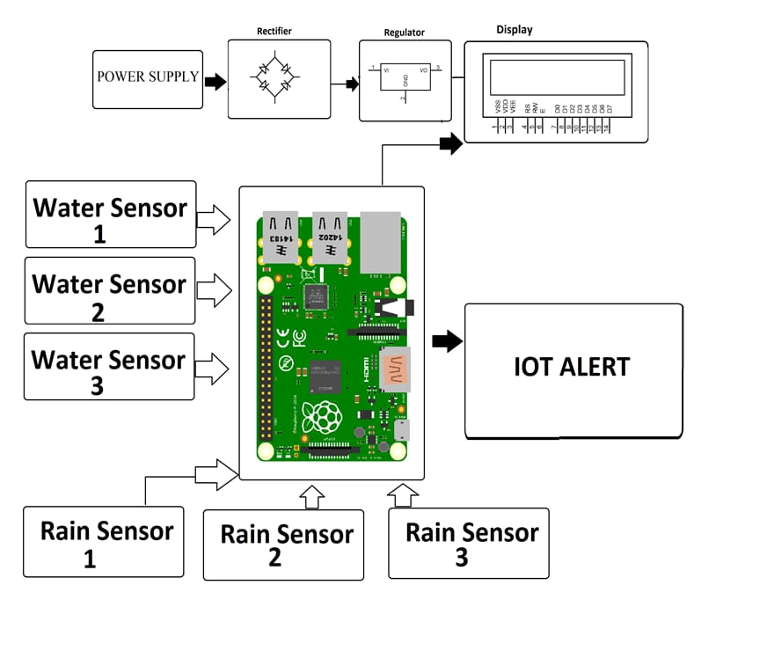IoT Sensors:

Water Level Sensors:Deploy water level sensors in flood-prone areas near rivers, streams, or low-lying regions.These sensors use ultrasonic or pressure-based technology to measure water levels.The data collected by these sensors is crucial for flood detection.Rainfall Sensors:Install rainfall sensors to monitor precipitation in the region.These sensors measure rainfall intensity and duration.Rainfall data is important for assessing flood risk.Communication:IoT sensors are equipped with wireless communication modules (e.g., Wi-Fi, LoRa, or cellular) to transmit data to the central platform.Data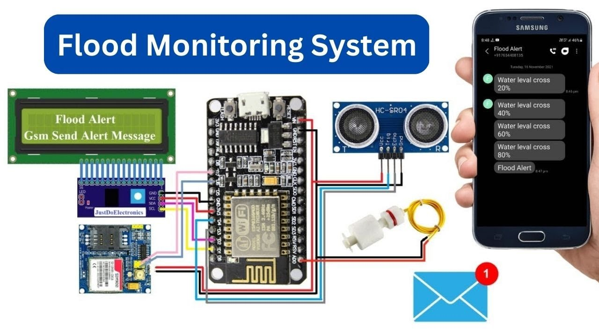 Transmission:Sensors periodically send data (water levels and rainfall) to the central platform.The data is time-stamped for real-time monitoring.

Early Warning Platform:

Data Reception:The early warning platform receives data from IoT sensors.Data is processed and stored in a database for analysis.Data Analysis:The platform processes incoming sensor data to assess flood risk.Algorithms analyze water level and rainfall data to detect anomalies.Alert Generation:When the platform detects abnormal conditions indicating potential flooding, it generates alerts.Alerts can be in the form of messages, emails, or notifications.User Interface:The platform provides a user-friendly interface to display real-time sensor data, flood risk assessments, and alerts.Users can access this interface to stay updated on the situation.Public Alerts:The platform can issue alerts to the public through various communication channels, such as SMS, email, and mobile apps.Emergency Services Coordination:The system can also alert emergency services and relevant authorities, enabling them to respond promptly to flood situations.Historical Data and Reporting:The platform stores historical sensor data for future analysis and reporting.Users can access historical data to study flood patterns.

**Enhancing Public Safety:**

The real-time flood monitoring and early warning system enhances public safety and emergency response coordination in the following ways:

1. Early Alerts: The system can provide early warnings to residents, emergency services, and local authorities, allowing them to take preventive measures.

2. Data-Driven Decision-Making: Real-time data from IoT sensors helps authorities make informed decisions regarding evacuations and resource allocation during flood events.

3. Public Awareness: The platform provides access to real-time data for the public, increasing awareness about local flood risks and safety measures.

Submission:

**GitHub Repository Link:** <https://github.com/GOWSALYA21/GOWSALYA-K>

**Replication Instructions:**

To replicate the project, follow these steps:

1. Set up the IoT sensor network in flood-prone areas as per the deployment schematics provided.

2. Clone the GitHub repository containing the project code.

3. Install the required Python libraries and dependencies mentioned in the project documentation.

4. Configure the platform settings and connect it to the deployed IoT sensors.

5. Run the Python scripts to start data collection and processing.

6. Access the early warning platform using a web browser to monitor real-time data and receive alerts.

**Example Include example outputs of IoT sensor data transmission and platform UI. **

import requests

import json

import time

# Example data to be transmitted

data = {

"sensor_id": 1,

"temperature": 25.5,

"humidity": 60.2

}

# API endpoint to receive the data on the server

api_url = "http://your-server-endpoint.com/data"

while True:

try:

# Send the data to the server

response = requests.post(api_url, json=data)

# Check the response status

if response.status_code == 200:

print("Data transmitted successfully")

else:

print("Failed to transmit data:", response.status_code)

except requests.exceptions.RequestException as e:

print("Exception occurred:", e)

# Wait for a specific interval before sending the next data

time.sleep(5) # Adjust the delay as per your requirements

Mobile App UI (Example using Flutter):

```dart

import 'package:flutter/material.dart';

class TransitInformationApp extends StatelessWidget {

@override

Widget build(BuildContext context) {

return MaterialApp(

title: 'Transit Information',

home: Scaffold(

appBar: AppBar(

title: Text('Transit Information'),

),

body: Center(

child: Column(

mainAxisAlignment: MainAxisAlignment.center,

children: <Widget>[

Text(

'Temperature: 25.5°C',

style: TextStyle(fontSize: 20),

),

Text(

'Humidity: 60.2%',

style: TextStyle(fontSize: 20),

),

// Add more widgets to display additional transit information

],

),

),

),

);

}

}

void main() {

runApp(TransitInformationApp());

}